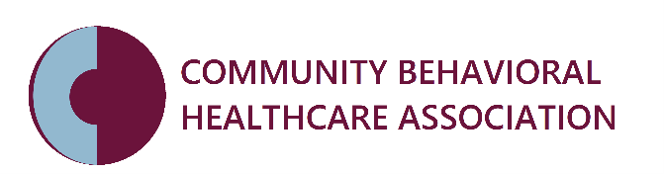
REQUEST FOR PROPOSAL 2022
“Ensuring and Enhancing the Clinical Skills of the IL Children’s Mental Health Workforce”

Please complete the following questions and return application to Michelle Churchey-Mims at mchurchey-mims@cbha.net by 6/10/22 at 5pm.
OVERVIEW
1) Organization Name

2) Project Title

3) Project Abstract

4) Total Project Budget Request-The allowable budget is $53,000.

5) Project Start Date
6) Project End Date

ORGANIZATION INFORMATION
7) President/CEO/Executive Director
Name/Title

8) President/CEO/Executive Director
E-mail

9) Address

10) City

11) State

12) Postal Code

13) County

14) Phone

15) Email Address

16) Organizational background: Please provide a brief description of your organization, including mission and population/communities served.

17) Annual Budget

18) Tax ID

APPLICATION PRIMARY CONTACT PERSON INFORMATION
This person will receive all communication related to the application.
19) Name/Title

20) E-mail

21) Office Phone/including extension

22) Mobile Phone

PROJECT DIRECTOR INFORMATION
This person will be the staff person in charge of operational management and implementation.
23) Name/Title

24) E-mail

25) Office Phone/including extension

26) Mobile Phone

PROJECT DEFINITION
A) Describe your agency’s history and experience in providing children’s mental health services.

B) How many youth received mental health services at your agency in FY21?

C) If you provided children’s mental health services in Chicago, how many youth received mental health services in the city of Chicago at your agency in FY21?

D) How many LPHA clinicians do you have who are trained in children’s mental health services?

E) Describe your model of clinical supervision (i.e., who provides the supervision, frequency, orientation, etc.)

F) Describe your agency’s training plan.

G) Describe your agency’s experience in training and use of Evidence Based/Informed Practices (what EB/EI practices are used; do you use an electronic clinical practice support tool?).

H) Describe your history and relationships with master’s degree programs. Describe how you would recruit, train and support four 2nd year master’s students each year.

I) How many license eligible staff do you have who need clinical supervision to advance them to licensure?

