HAH Coronavirus Triage Workflow
Ask every participant calling for an appointment:
- What is the reason for your appointment?
- Do you have a fever, cough, shortness of breath or difficulty breathing?
- Have you traveled to China, Iran, Italy, Japan or South Korea OR had close contact with a person known to have COVID-19 in the last 14 days?

CDC epidemiologic information to obtain – use Centricity quicktext .covid
- Assess symptoms: fever, cough, shortness of breath or difficulty breathing and duration
- Assess for other presenting symptoms and duration
- Obtain travel dates, location
- Have you recently been in a healthcare facility with known COVID-19 Infection?
- Have you been around individuals who had a respiratory illness (i.e. fever, pneumonia requiring hospitalization)?
- Do you have any other chronic medical problems?
- Have you had any recent testing for your respiratory symptoms?

INCOMING CALLS: IDENTIFY

YES Symptoms +  Travel/Exposure | Yes Symptoms  No Travel/Exposure | No Symptoms  Yes Travel/Exposure | No Symptoms  No Travel/Exposure
- Obtain participant’s name, DOB, and phone number.  - Inform participant a RN will follow-up.  - Page available RN, if none available call Melissa 312-339-6341 immediately.  - See, Assess Clinical Status. | - Obtain participant’s name, DOB, and phone number.  - Inform participant a RN will follow-up.  - Page available RN, if none available call Melissa 312-339-6341 immediately.  - See, Assess Clinical Status. | - Obtain participant’s name, DOB, and phone number.  - Inform the participant a RN will follow-up.  - Contact designated RN and provide details of call.  - RN will instruct participant to monitor for COVID-19 symptoms and to call clinic if symptoms present. | - No further action required.  - Schedule an appointment.
- CRT will notify designated HAH infection control personnel Dr. Evan Lyon, 312-343-1571 for consult.
- Based on consult with Dr. Evan Lyon, determination to contact and report participant to the Chicago Department of Public Health (CDPH) will be made.
- If required, RN will call the Chicago Department of Public Health Call 312-746-SICK (7425).
- If no further action required, RN will provide participant with home care guidance, see appendix B.
CRT: INFORM

CRT (COVID19 Response Team): ASSESS CLINICAL STATUS

Ask every participant scheduling or registering for an appointment:
- What is the reason for your appointment?
- Do you have a fever, cough, shortness of breath or difficulty breathing?
- Have you traveled to China, Iran, Italy, Japan or South Korea OR had close contact with a person known to have COVID-19 in the last 14 days?

IN-CLINIC: IDENTIFY (first contact with participant)

Yes Symptoms  No Travel/Exposure | No Symptoms  Yes Travel/Exposure | No Symptoms  No Travel/Exposure
- Give participant surgical mask.  - Page CRT team.  - See next box, Isolate. | - Give participant surgical mask.  - Page CRT team.  - See next box, Isolate. | - No further action required.  - Schedule an appointment.

YES Symptoms +
Travel/Exposure
Give participant surgical mask.

- Give participant a surgical face mask and ensure the participant is wearing it.
- Ask the participant to stand in the designated holding area (keep participants and staff more than 6 feet of participant):

  - Uptown Clinic- holding area in stairwell by front door or MLK room, behind blue line.
  - Englewood Clinic- immediately direct participant to go into Triage Room 2.
  - James West Clinic- left side of front desk, corner space by glass window.

- Page CRT team designated at huddle daily. The team member will place proper PPE on prior to escorting
participant: an N95 mask, gown, gloves, face shield or goggles. Escort to designated isolation rooms:

- Uptown Clinic – Exam room 1, if more than one person needs to be isolated continue using exam rooms in order.
  - Englewood Clinic – Triage Room 2, if more than one person needs to be isolated continue using exam rooms in order.
  - James West Clinic – Exam room 10, if more than one person needs to be isolated continue using exam rooms in descending order.
- Place COVID-19 PPE Sign for standard, contact, and airborne precautions (see appendix A) in front of isolation room.
- Notify the Clinic Health Manager, Christopher Ervin -- 312-859-5216 or Sheena Ward -- 312-497-6269, who will inform Dr. Evan Lyon -- 312-343-1571 for further guidance. See next page for clinical assessment guidance and testing.
Reference: Chicago Department of Public Health – COVID-19 -- https://www.chicagohan.org/covid-19

ISOLATE – COVID-19 Team (CRT)

CDC requires the collection of one upper respiratory specimen:
- Nasopharyngeal (NP) Swab only
- Use collection devices provided by Quest: Use only synthetic fiber swabs with plastic shafts. Do not use calcium alginate swabs or swabs with wooden shafts, as they may contain substances that inactivate some viruses and inhibit PCR testing. Place swabs immediately into sterile tubes containing 2-3 ml of viral transport media. In general CDC is now recommending collecting only the NP swab. If both swabs are used, NP and OP specimens should be combined at collection into a single vial.
- Nasopharyngeal swab: Insert a swab into the nostril parallel to the palate. Leave the swab in place for a few seconds to absorb secretions.
- Order Test Name: SARS-CoV-2 RNA, Qualitative Real-Time RT-PCR Test Code: 39433 -- order must be its own encounter and ordered separately from other tests
- Provide specimen to Quest lab tech for processing.
EDUCATE AND DISCHARGE HOME

- If approved by the CDPH, discharge participant home with home care guidance sheet, see appendix B.
- Instruct participant to monitor for developing or worsening symptoms of fever or respiratory illness. Provide education on respiratory and hand hygiene.
- Advise participant to call clinic for any questions or if feeling the need to be reevaluated.
COLLECT SPECIMENS

- Consult with Dr. Evan Lyon after provider evaluates the participant for COVID-19 risks. Will await recommendation from Evan prior to calling CDPH.
- If required, clinical staff will call the CDPH 312-746-SICK (7425) to report the PUI, but not to request permission to test. Testing will be completed through our Quest services.
- Discuss the case and follow guidance from CDPH provider.
- A RN or provider will complete the assessment. The individual should use the following PPE: an N95 mask, gown, gloves, face shield or goggles to assess participant for symptoms.
- If not all available PPE is found, the RN or provider will call into isolation room to avoid potential exposure.
CDC epidemiologic information to obtain:
- Assess symptoms: fever, cough, shortness of breath or difficulty breathing and duration
- Assess for other presenting symptoms and duration
- Obtain travel dates, location
- Have you recently been in a healthcare facility with known COVID-19 Infection?
- Have you been around individuals who had a respiratory illness (i.e. fever, pneumonia requiring hospitalization)?
- Do you have any other chronic medical problems?
- Have you had any recent testing for your respiratory symptoms?

INFORM- Provider/RN

ASSESS CLINICAL STATUS – CRT

Appendix A– COVID-19 Personal Protective Equipment (PPE) Guide

COVID-19 ISOLATION
PRECAUTIONS

STANDARD, CONTACT, AIRBORNE PRECAUTIONS

To prevent the spread of infection,
Anyone entering this room MUST wear
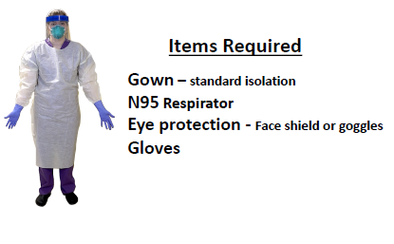

Ensure the DOOR to the participant’s room
Remains CLOSED at all times.

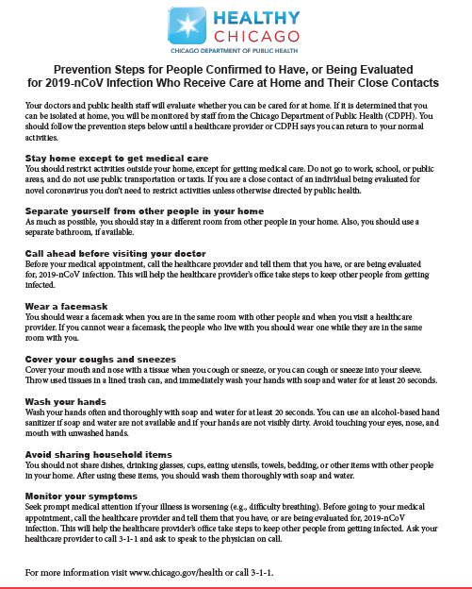
Appendix B– Home Care Guidelines

Appendix C- CDC Healthcare Personnel Exposure Guidance

Interim U.S. Guidance for Risk Assessment and Public Health Management of Healthcare Personnel with Potential Exposure in a Healthcare Setting to Patients with Coronavirus Disease (COVID-19)
Reference: https://www.cdc.gov/coronavirus/2019-ncov/hcp/guidance-risk-assesment-hcp.html
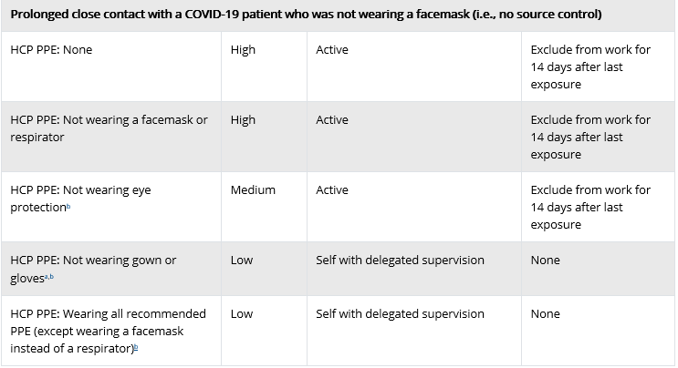
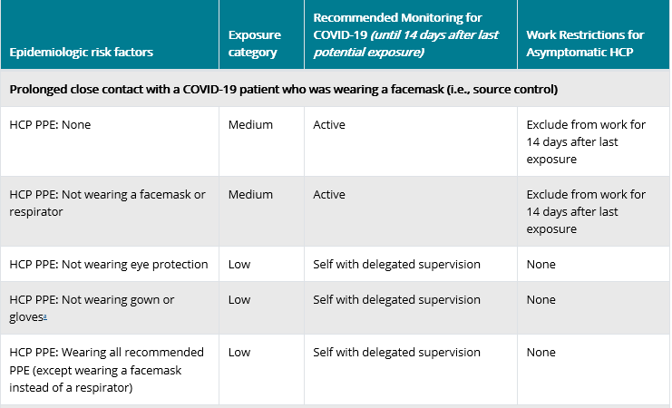
Updating recommendations regarding HCP contact tracing, monitoring, and work restrictions in selected circumstances. These include allowances for asymptomatic HCP who have had an exposure to a COVID-19 patient to continue to work after options to improve staffing have been exhausted and in consultation with their occupational health program.

Appendix D- Interim Infection Prevention and Control Recommendations for Patients with Suspected or Confirmed Coronavirus Disease 2019 (COVID-19) in Healthcare Settings
Full Reference go to:
https://www.cdc.gov/coronavirus/2019-ncov/infection-control/control-recommendations.html
