Tips for Therapy during Covid-19
- You can find lots of great facts, use them, not opinions / theories.
- Prepare yourself for the questions, concerns about COVID-19 [and how IMHC is handling it], coping strategies etc.
Or defer questions to your D.O.N, CDC, WHO, etc.
- Remember – people are only concerned about toilet paper ;)
- Super useful CDC link for facts and resources: https://www.cdc.gov/coronavirus/2019-ncov/prepare/managing-stress-anxiety.html
- -- Most of the following is directly from this site --
  - Take your client’s lead, if they wish to discuss it - okay, if not - don’t make it the focus, but check in on how they’re feeling what their next few weeks will look like.
    - Some lives may be the same
    - Some lives may be drastically affected
      - Create coping skills / routines / strategies with them
  - Listen for indicators during their conversation:
Stress during an infectious disease outbreak can include
    - Fear and worry about your own health and the health of your loved ones
    - Changes in sleep or eating patterns
    - Difficulty sleeping or concentrating
    - Worsening of chronic health problems
    - Increased use of alcohol, tobacco, or other drugs

  - Things for therapists/parents to encourage child / teen / client:
    - There are many things you can do to support them
    - Take time to talk with your child / teen / client about the COVID-19 outbreak. Answer questions and share facts about COVID-19 in a way that your child / teen / client can understand.
    - Reassure your child / teen / client that they are safe. Let them know it is ok if they feel upset. Share with them how you deal with your own stress so that they can learn how to cope from you.
    - Limit your family’s exposure to news coverage of the event, including social media. Children may misinterpret what they hear and can be frightened about something they do not understand.
    - Try to keep up with regular routines. If schools are closed, create a schedule for learning activities and relaxing or fun activities.
    - Be a role model. Take breaks, get plenty of sleep, exercise, and eat well. Connect with your friends and family members.

  - Things you can do to support yourself:
    - Take breaks from watching, reading, or listening to news stories, including social media. Hearing about the pandemic repeatedly can be upsetting.
    - Take care of your body. Take deep breaths, stretch, or meditate. Try to eat healthy, well-balanced meals, exercise regularly, get plenty of sleep, and avoid alcohol and drugs.
    - Make time to unwind. Try to do some other activities you enjoy.
    - Connect with others. Talk with people you trust about your concerns and how you are feeling
    - Routines, routines, rest, and more routines for yourself, loved ones, and encourage it for clients.
    - Don’t play a hero, stay home if feeling the warning symptoms!
No need to be an expert in this, but also don’t forget:
No one cares how much you know, until they know how much you care.
-Teddy Roosevelt

PDF available at the link: https://www.cdc.gov/coronavirus/2019-ncov/about/share-facts-h.pdf
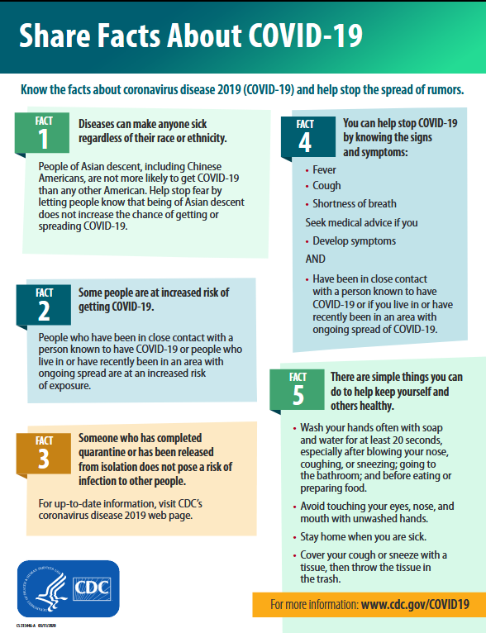
Tips for doing therapy electronically (various sources)
For You (Preparation):
- It does have to be private. If someone else is in the room it will affect the process. – Shut your door.
- Free yourself from distractions. Please silence your other alerts / music.
- Headphones. It changes the whole dynamic of the therapy session.
It feels more private, there is less feedback and you are able to hear more clearly.
- Speaker phone. You will be able to sit further away, be more comfortable and still hear your client clearly. Body language is just as important as verbal language; let’s not limit ourselves just because we're doing counseling via phone. (Be sure the volume isn’t too high.)
- Don’t try and do other paperwork. You will lose focus too easily. Be Present. Have a pad to write notes on or sketch to stay focused.
- Use your charting system. Pull up their chart, so you can see their goals and other pointers from last sessions. It’ll help the process go more smoothly. Be sure not to be typing or clicking around too much though, as that’ll be distracting for you both.
- Clock... or not. This is very much a personal choice as some people prefer not to know the time. However if you think you need a clock to monitor yourself during the session then you can arrange one nearby.
- Printing the Tips for Therapy during Covid-19 (or similar factual info) may be helpful to look at or have handy in sessions / while doing a phone session.
For you / the client @ start of session:
- Ask Client where they are: Ask them to simply verify their address or location’s address at the start of each session. (In case of a suicide threat or crisis) They may be at a family member’s home, or elsewhere.
- Ask Best Way to reach them if a disconnection and that you’ll call them back: incase the number you called isn’t the best phone, maybe a land line or another’s cell. (Again, also in case of a suicide threat or crisis)
- Request: No children or other adults in the room with them during their session. This is their time. Even if they need to go into the bathroom, sit in their car, back porch etc.
- Relax: It can be awkward at first to keep a conversation going, but it’ll work! Use their chart for tips / questions.
- Schedule F/U sessions, remind of crisis lines & ability to speak sooner.

